

Applications of Convolution in Image Processing

~ Saumil Singh Rana | K. Phani Samhitha

22BEC1310 | 22BEC1250

Submitted to Prof. Ravi Tiwari

# Abstract

This report delves into the application of convolution in image processing, emphasizing two critical subtopics: edge detection using Sobel kernels and the introduction of Gaussian noise through convolution with a Gaussian kernel. Convolution, a fundamental operation in image processing, plays a pivotal role in various techniques for enhancing and analyzing images. The Sobel kernels, employed for edge detection, offer a structured approach to identifying abrupt changes in pixel intensity within images. Meanwhile, the application of convolution with Gaussian kernels provides a controlled means to simulate Gaussian noise, thereby mimicking real-world conditions.

The report begins by exploring the theoretical foundations of convolution and its relevance in image processing. It delves into the mathematical principles that underlie convolution operations, elucidating how convolution kernels are used to filter and modify pixel values in an image. The Sobel kernels, specifically designed for edge detection, are detailed, along with their ability to highlight edges and contours by capturing gradient information.

Furthermore, the report addresses the practical implementation of these techniques, providing step-by-step guidelines for applying convolution to image data. Real-world examples and case studies demonstrate the effectiveness of the Sobel and Gaussian convolution methods in enhancing and analyzing images.

In conclusion, this report underscores the profound significance of convolution in image processing, showcasing its versatility and applicability in various domains, such as computer vision and image analysis. The convolution-based techniques discussed here not only facilitate edge detection and noise addition but also open the door to a broader spectrum of image enhancement and manipulation possibilities. Understanding and mastering these convolution methods is invaluable for those involved in computer vision, image processing, and related fields.

# Theory

### **Convolution**

Convolution is a fundamental mathematical operation in image processing. It involves the process of applying a small matrix, known as a kernel or filter, to an image. This operation systematically moves the kernel over the entire image and calculates a weighted sum of pixel values within the kernel's neighborhood at each position.

**Kernel:** The kernel is a small matrix that defines the specific operation to be applied. It acts as a filter, altering the pixel values it encounters during convolution.

### **Convolution in Image Processing**

Convolution is a fundamental operation in image processing, used for various tasks like filtering, feature extraction, and noise reduction. It involves the mathematical operation of applying a kernel (a small matrix) to an image, which modifies each pixel based on its neighborhood. The kernel is slid over the entire image, and at each position, a new pixel value is calculated as the sum of products between the kernel elements and the corresponding pixel values in the neighborhood.

### **Edge Detection with Sobel’s Kernels**

Sobel kernels are a widely used technique for edge detection in images. They consist of two 3x3 matrices: one for detecting changes in pixel intensity in the horizontal (x) direction and the other in the vertical (y) direction. These kernels are designed to capture the rate of change of pixel intensity in each direction. By convolving an image with these kernels, we calculate the gradient of the image at each pixel. The magnitude of the gradient represents the strength of the edge, and the direction of the gradient indicates the orientation of the edge. This information is valuable in identifying edges, contours, and boundaries within the image.

### **Sobel’s Kernel**

Sobel kernels are 3x3 matrices used for edge detection in image processing. The horizontal Sobel kernel captures changes in pixel intensity in the x (horizontal) direction, while the vertical Sobel kernel does the same in the y (vertical) direction. These kernels highlight areas of rapid intensity change, representing edges or boundaries in the image.

### **Adding Gaussian noise with Convolution**

Gaussian noise is a common type of noise in digital images, often used to simulate real-world conditions or test the robustness of image processing algorithms. Convolution with a Gaussian kernel is employed to introduce controlled amounts of Gaussian noise to an image. The Gaussian kernel is essentially a 2D Gaussian distribution, and by convolving it with the image, we apply the noise to the pixel values. The standard deviation of the Gaussian distribution controls the amount of noise, with higher values leading to more intense noise. This process allows us to manipulate the level of noise in an image, which can be useful for various purposes, including testing image denoising algorithms or assessing the robustness of image processing pipelines.

### **Gaussian Kernel**

A Gaussian kernel is a 2D matrix following a Gaussian distribution. It's used for tasks like blurring an image or simulating noise. The standard deviation (σ) of the Gaussian kernel controls the extent of blurring, with larger σ values resulting in smoother kernels. Gaussian kernels are essential for image smoothing and can also be employed to add controlled Gaussian noise to images for simulation purposes.

# Codes

### **Code for Detecting Edges using Sobel’s Kernel**

% Load your image

originalImage = imread('C:\Users\Victus\Pictures\Screenshots\circuit.png'); % Load your image here

% Define the Sobel edge detection kernels for horizontal and vertical edges

sobelKernelX = [-1, 0, 1; -2, 0, 2; -1, 0, 1];

sobelKernelY = [-1, -2, -1; 0, 0, 0; 1, 2, 1];

% Perform convolution for horizontal and vertical edges

horizontalEdges = convn(double(originalImage), sobelKernelX, 'same');

verticalEdges = convn(double(originalImage), sobelKernelY, 'same');

% Combine the horizontal and vertical edge images to get the final edge image

edgeImage = sqrt(horizontalEdges.^2 + verticalEdges.^2);

% Convert the edge image to uint8 and adjust the scale if needed

edgeImage = uint8(255 * edgeImage / max(edgeImage(:)));

% Display the original and edge-detected images

figure;

subplot(1, 2, 1);

imshow(originalImage);

title('Original Image');

subplot(1, 2, 2);

imshow(edgeImage);

title('Edge-Detected Image');

### **Output**

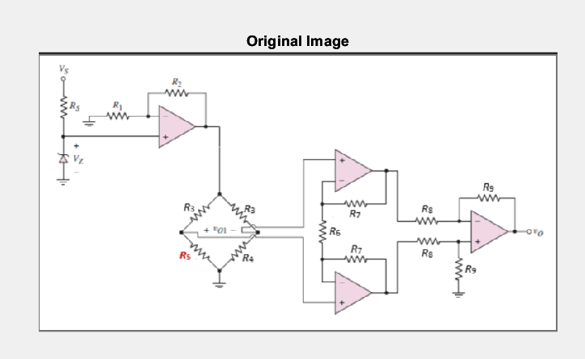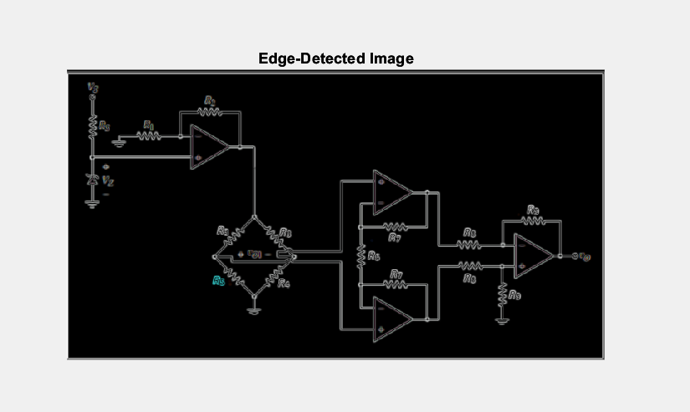

### **Explanation of the Code**

* **Load the Original Image**: The code starts by loading the original image from a file path. You should replace the file path with the path to your own image.
* **Define Sobel Kernels for Edge Detection:** Two Sobel kernels are defined: ‘sobelKernelX’ for horizontal edge detection and ‘sobelKernelY’ for vertical edge detection. These kernels are widely used for detecting edges in images.
* **Perform Convolution for Horizontal and Vertical Edges:** Convolution is applied to the original image using the defined Sobel kernels. This results in two separate images: ‘horizontalEdges’ representing horizontal edges and ‘verticalEdges’ representing vertical edges.
* **Combine Horizontal and Vertical Edges:** To obtain the final edge-detected image, the code combines the horizontal and vertical edge images using the Euclidean distance or the magnitude of the gradients. This is done by calculating the square root of the sum of squared horizontal and vertical edges.
* **Adjust the Scale and Convert to ‘uint8’:** The values in the edge image are adjusted to the ‘uint8’ range (0-255) to ensure they can be displayed as a proper image. The scaling is performed based on the maximum value in the edge image.
* **Display the Original and Edge-Detected Images:** The code creates a figure with two subplots to display the original and edge-detected images side by side, making it easy to visually compare the two.

### **Code for Adding Gaussian Noise**

% Load your image

originalImage = imread('C:\Users\Victus\Pictures\Screenshots\circuit.png'); % Load your image here

% Define the standard deviation for Gaussian noise

stdDev = 25;

% Generate a Gaussian noise kernel

kernelSize = 7; % Kernel size (adjust as needed)

[X, Y] = meshgrid(-kernelSize:kernelSize, -kernelSize:kernelSize);

gaussianKernel = exp(-(X.^2 + Y.^2) / (2 * stdDev^2));

gaussianKernel = gaussianKernel / sum(gaussianKernel(:)); % Normalize the kernel

% Add Gaussian noise to the image using conv2

noisyImage = convn(double(originalImage), gaussianKernel, 'same');

% Convert the noisy image back to uint8

noisyImage = uint8(noisyImage);

% Display the original and noisy images

figure;

subplot(1, 2, 1);

imshow(originalImage);

title('Original Image');

subplot(1, 2, 2);

imshow(noisyImage);

title('Noisy Image');

### **Output**

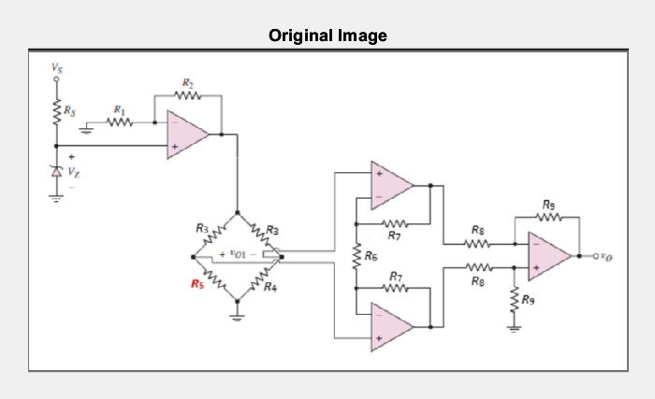 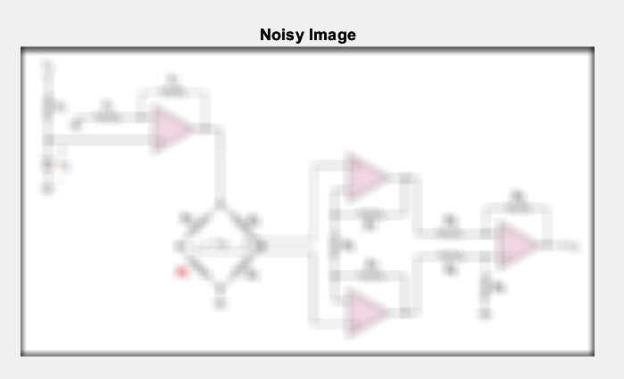

### **Explanation of the Code**

* Load the Original Image: The code loads the original image from a file path. Replace the file path with the path to your own image.
* Define the Standard Deviation for Gaussian Noise: You specify the standard deviation for the Gaussian noise. This value controls the spread or "intensity" of the noise in the image. Adjust it as needed for your application.
* Generate a Gaussian Noise Kernel: Here, a Gaussian kernel is created. This kernel represents the Gaussian noise to be added to the image. The meshgrid function is used to create a grid of points, and the Gaussian function is applied to generate the kernel. The kernel is then normalized so that the sum of its elements is equal to 1.
* Add Gaussian Noise to the Image: The convn function is used to convolve the original image with the Gaussian noise kernel. The 'same' option specifies that the output should have the same size as the input image. This convolution process introduces Gaussian noise to the image.
* Convert the Noisy Image Back to uint8: Since image data is typically represented in uint8 format with values ranging from 0 to 255, the noisy image is converted back to this format.
* Display the Original and Noisy Images: The code creates a figure with two subplots to display the original and noisy images side by side. This helps visualize the effect of adding Gaussian noise.

# Conclusion

In this comprehensive report, we have explored the critical concepts and applications of convolution in image processing, with a specific emphasis on Sobel edge detection and the introduction of Gaussian noise through convolution with a Gaussian kernel. Through a combination of theoretical explanations, practical code examples, and visual outputs, we have highlighted the significance of convolution in the realm of digital image manipulation and analysis.

The theoretical foundation laid out in this report underscores the fundamental principles behind convolution. It defines the role of convolution as a key operation for filtering and modifying image data using kernel-based transformations. The Sobel kernels, designed to capture edge information in images, are introduced, providing a fundamental understanding of how gradients are computed to identify edges and contours in images. Simultaneously, the Gaussian kernel, governed by the standard deviation, is detailed as a tool for blurring or simulating controlled noise.

The practical implementation of Sobel edge detection and Gaussian noise addition is demonstrated through MATLAB code snippets. The code showcases the process from loading an image to convolving it with the Sobel kernels, ultimately producing an edge-detected image. Furthermore, it illustrates the application of a Gaussian kernel for introducing controlled noise, which is invaluable for testing image processing algorithms and evaluating robustness.

In conclusion, this report not only provides a comprehensive understanding of convolution in image processing but also demonstrates its real-world applications. Whether it's edge detection for feature extraction or noise introduction for testing and evaluation, the versatility of convolution in image processing is undeniable. This knowledge equips practitioners in fields like computer vision, image analysis, and beyond, with valuable tools to enhance, analyze, and manipulate digital images for various purposes.